WORKSHOP 21

Pitfalls 1

although the id validates well, it does not validate on the first and last names

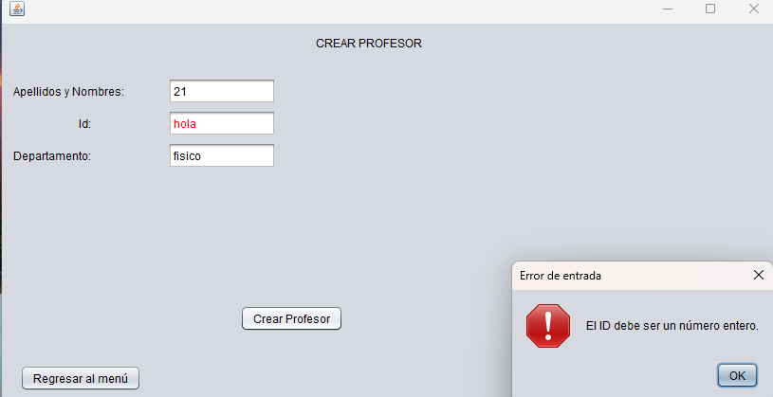

Pitfalls 2

the capital letter of the name “Camilo” is not valid.

